Tomb Monuments in Medieval Europe: Volume II
Edited by Paul Cockerham and Christian Steer
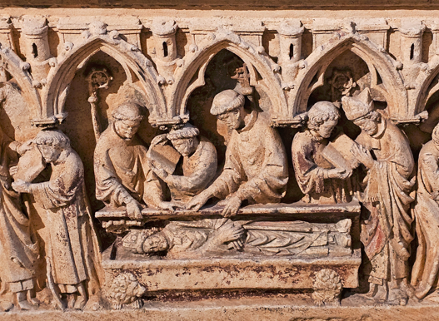
This the second of a three-volume series brings together a new group of international experts who consider the development, growth and purpose of funerary commemoration during the Later Middle Ages. They reflect on questions raised in volume I, examining the circumstances for individual commissions, local, regional and national patterns and the importance and influence of patronage in the period from c.1300. Essays also reflect on the language of memorial inscriptions and the role of audience. Contributors consider such developments in Burgundy, England, France, the Holy Roman Empire, Iberia, the Italian States, Naples, Poland, Portugal, Scotland and the Spanish Netherlands. This important new publication includes eighteen essays by a range of international specialists in their field:
ANN J. ADAMS ♦ TRUDI BRINK ♦ NICOLA BUSINO ♦ JAKOV ÐORÐEVIĆ ♦ LUKE GIRAUDET ♦ PAMELA KING ♦ JOHN S. LEE ♦ DAVID LEPINE ♦ EMMA LIAÑO MARTÍNE ♦ JULIAN LUXFORD ♦ MARCUS MEER ♦ ÉLISE-ANNUNZIATA NEUILLY ♦ RICHARD D. ORAM ♦ PABLO ORDÁS DÍAZ ♦ JORGE PORTAL LIAÑO ♦ CHRISTIAN STEER ♦ MICHELE TOMASI ♦ GIULIA ROSSI VAIRO ♦ MAREK WALCZAK
This volume, published in English throughout, will be richly illustrated with both colour and black and white images and will be fully indexed. A List of Subscribers will be included with the names of those who pre-order a copy by 31st July 2026 available at a special pre-publication offer of £30 (post-free in the U.K., an extra £20 for overseas P&P). To order a copy please send the slip below, with a cheque made payable to Shaun Tyas Publishing, to Dr Christian Steer, 8 Shefford Lodge, Link Road, Newbury, Berkshire, RG14 7LR; alternatively to pay by PayPal or to pay by bank transfer please email Dr Steer at: christianosteer@yahoo.co.uk for further details.
_____________________________________________________________________________________
Name to appear in the List of Subscribers (no titles): ……………………………………………………….
Please send ….. copy/ies of Tomb Monuments in Medieval Europe II to (name): ………………………….
(address): ………………………………………………………………………………………………..
………………………………………………………………………………………………………………..
……………………………………………………………………………………………………………….
In case of query please provide your telephone number or email address:
…………………………………………………………………………………………….............................
TABLE OF CONTENTS
- Élise-Annunziata Neuilly Virtues for Eternity: Adopting the virtutes cardinales on Royal Funerary Tombs in Medieval Europe
- Giulia Rossi Vairo ‘Until death us do part’: The Tomb Monuments of Dinis of Portugal (d.1325) and Isabel of Aragon (d.1336) and the Innovation in Funerary Sculpture in Late Medieval Portugal
- Emma Liaño Martíne and Jorge Portal Liaño The Monastery of Poblet (Catalonia): A Pantheon of the Kings of Aragon and the Royal Infants (c.1340–c.1480)
- Pablo Ordás Díaz The Funerary Chapel of Bishop Juan del Campo (d.1344) in León Cathedral: Architectural Form, Episcopal Memory, and Political Representation
- Richard D. Oram ‘Rejoice to hear of Douglas!’: The Tomb Monuments of the ‘Black’ Douglases and the Celebration of the Douglas Lineage c.1331–c.1447
- Nicola Busino The Incised Slab of Bishop Azo (d.1310) at Casertavecchia (Italy) and the Walls of the civitas casertana: An Archaeological Examination
- Jakov Đorđević Unearthing the Sensations of the Holy Earth: The Camposanto of Pisa, the Great Cemetery-Reliquary (1300–1500)
- Michele Tomasi A Law Professor, the Friars, and the Rulers in Trecento Padua: The Tomb of Raniero Arsendi (d.1358) at the Basilica di Santo Antonio
- Julian Luxford The Late Medieval Tomb of King Athelstan at Malmesbury Abbey (Wiltshire)
- Christian Steer The Chantry Brass of John de Heylesdon (d.1384), Alderman and Mercer of London, at Hellesdon, Norfolk
- Marcus Meer ‘I know where my ancestors are buried’: Tomb Monuments in Family Books from German-Speaking Cities of the Later Middle Ages
- Luke Giraudet Bourgeois Networks and Commemorative Strategies: The Epitaphs of the Church and Cemetery of the Holy Innocents in Fifteenth-Century Paris
- John S. Lee Lincolnshire Wool Merchants and their Brasses in the Late Middle Ages
- Marek Walczak A Hunter and a Lord of Nature: Representations of Animals on the Tomb of King Ladislaus II Jagiełło of Poland (d.1434) in Cracow Cathedral Re-examined
- Pamela King The Late Medieval Cadaver Tomb Reconsidered
- David Lepine ‘So ravished all my wits’: The Pastoral and Didactic Functions of the Cadaver Tomb Monument of William Derby (d.1438) at Terrington St Clement (Norfolk)
- Ann J. Adams A Burgundian Knight in Black Marble: Jean de Luxembourg, ‘bâtard de Saint-Pol’, Seigneur of Haubourdin and Ailly-sur-Noye (d.1466)
- Trudi Brink Tools for Representation: Signed Tomb Slabs in pre-Reformation Friesland in the Spanish Netherlands (1535–80)

